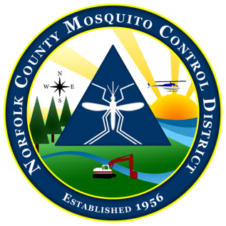
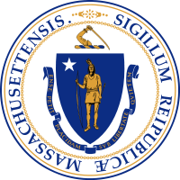

The Commonwealth of Massachusetts
The State Reclamation and Mosquito Control Board
Norfolk County Mosquito Control District
144 Production Road, Suite C, Walpole, MA 02081
(781) 762-3681 fax: (781) 769-6436
www.NorfolkCountyMosquito.org

Robin L. Chapell Norman P. Jacques Maureen P. MacEachern Linda R. Shea Richard J. Pollack, PhD
Commissioners

Caroline E. Haviland
Field Operations Manager
David A. Lawson
Director

To: Boards of Health

From: David A. Lawson, Director

Date: February 08, 2021

Re: Notice of Aerial Larval Control Application

In accordance with 333 CMR 13.04(7) (a & b), please consider this as notification of the potential spring (and summer if conditions warrant) aerial applications targeting mosquito larvae in the larger wetlands of the District.

The Norfolk County Mosquito Control District will potentially be conducting helicopter applications of biorational larvicides to control mosquito larvae, should conditions warrant. Go to the Districts website for targeted spring wetland locations. The summer wetland locations will be posted before any application should it be warranted. These potential applications will be conducted over specific large wetlands in the Towns of:

Avon/Bellingham/Braintree/Canton/Dedham/Dover/Foxboro/Franklin
Holbrook/Medfield/Medway/Millis/Milton/Needham/Norfolk/Norwood
Plainville/Quincy/Randolph/Sharon/Stoughton/Walpole/Westwood
Weymouth/Wrentham

Any potential applications will be conducted between April 5, and October 29, 2021.

The trade name of the possible formulations utilized will be any of the following: VectoBac GR (EPA Reg. #73049-486); VectoBac G (EPA Reg. #73049-10): VectoBac GS (EPA Reg. #73049-10) VectoLex FG (EPA Reg. #73049-20), Natular G30 (EPA Reg. #8329-83), Duplex-G (EPA Reg. #89459-93), Altosid XR-G (EPA Reg. #2724-451), FourStar Bti CRG (EPA Reg. #85685-4), Altosid P35 (EPA Reg. #89459-95), MetaLarv S-PT (EPA Reg. No. 73049-475). For further information contact David A. Lawson, Director at (781) 762-3681 or the Boards of Health in the towns listed above. Information is also available on line at www.norfolkcountymosquito.org

Respectfully submitted,

David A. Lawson

