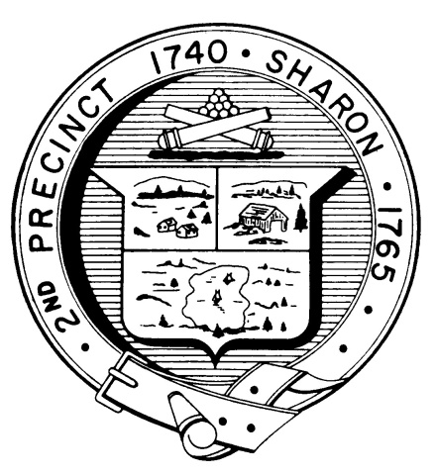

Town Clerk
TOWN OF SHARON

MEETING NOTICE

POSTED IN ACCORDANCE WITH THE PROVISIONS OF M.G.L. CHAPTER 39 SECTION 23A AS AMENDED.

FINANCE COMMITTEE
Monday, April 30th, 2018
7:30 p.m.
Town Hearing Room, Community Center, 219 Massapoag Avenue

AGENDA

OPEN WARRANT MEETING
Informal discussion of Warrant Articles
Monday, April 30 at 7:30pm
Town Hearing Room, Sharon Community Center, 219 Massapoag Avenue

The Open Warrant Meeting is an opportunity to ask questions regarding the Finance Committee Recommendations in the Annual Town Meeting Warrant.

Please take time to understand the issues.

Note: Items may not be discussed in the order listed or at the specific time estimated. Times are approximate.

The meeting likely will be broadcast and videotaped for later broadcast by Sharon Community Television

