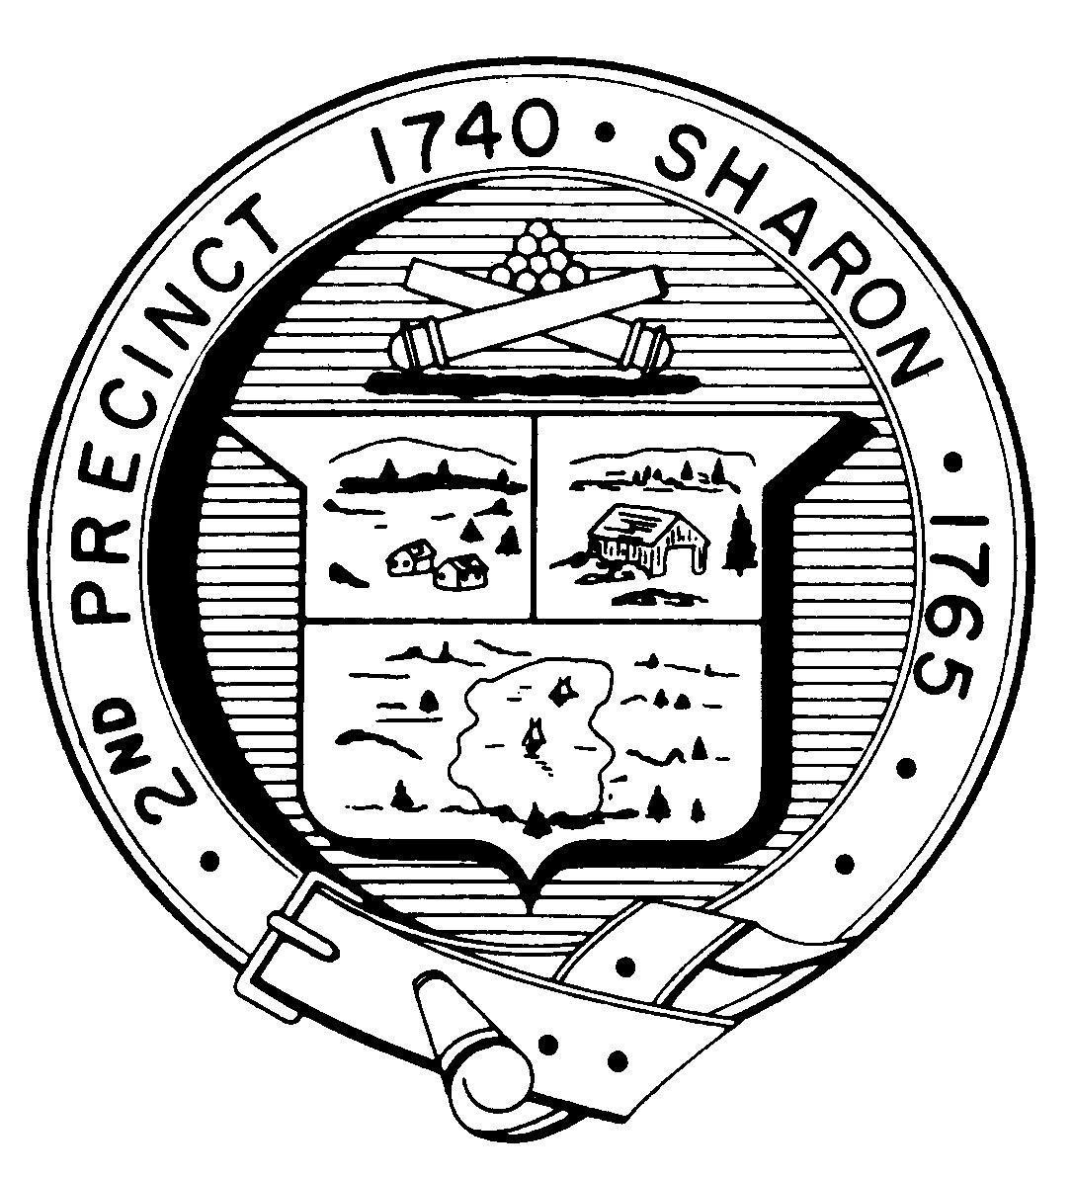

Town Clerk

TOWN OF SHARON
MEETING NOTICE

POSTED IN ACCORDANCE WITH THE PROVISIONS OF M.G.L. CHAPTER 39 SECTION 23A AS AMENDED.

Library Services Subcommittee

LOCATION: Sharon Public Library, 11 N. Main St, Lower-Level Community Room
DATE & TIME: October 19, 2022, 6:30 p.m.

AGENDA

Discuss Timeline and Process for Director Review

