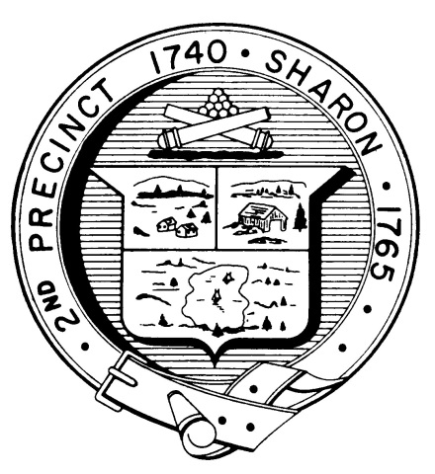

Town Clerk
TOWN OF SHARON

MEETING NOTICE

POSTED IN ACCORDANCE WITH THE OPEN MEETING LAW AS AMENDED

Board of Health

DATE: November 1, 2018

TIME: 7:00 pm

LOCATION: Sharon Community Center

AGENDA

- Meeting Minutes, September 26,2018 7:00 pm

- 7 Robin Road septic review 7:05 pm

- Article 7 Revisions 7:30 pm

- Innovative/Alternative systems proposal 8:45 pm

- “Stop the Bleed” kits 8:55 pm

- Follow up tobacco/vaping presentation 9:05 pm

- Health Department report 9:15 pm
- Other business 9:25 pm

