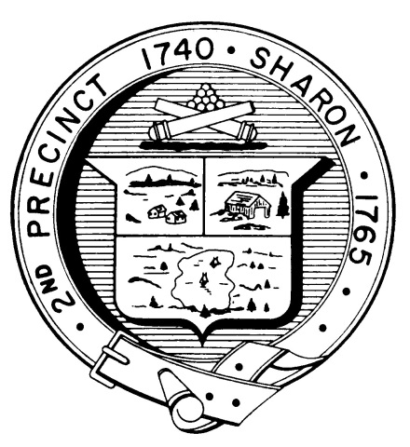

Town Clerk
TOWN OF SHARON

MEETING NOTICE

POSTED IN ACCORDANCE WITH THE OPEN MEETING LAW AS AMENDED

Board of Health

DATE: October 19, 2016

TIME: 7:00 pm

LOCATION: Sharon Community Center

AGENDA

- Minutes September 14,2016 meeting 7:00 pm

- Beach closure and testing issues 7:05 pm

- 109 Moose Hill Parkway septic 7:10 pm

- 62 South Main St. 7:30 pm

- 35 Chessman issues 7:35 pm

- PHEP grant $5,000 7:40 pm

- Break Flu Clinic 7:50 pm

- Health Department Report 8:30 pm

- Health Department roles discussion 8:40 pm

- Other business 9:00 pm

