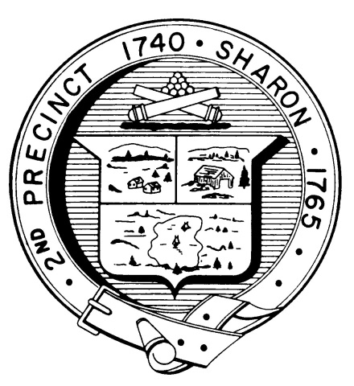

Town Clerk
TOWN OF SHARON

MEETING NOTICE

POSTED IN ACCORDANCE WITH THE OPEN MEETING LAW AS AMENDED

Board of Health

DATE: May 17, 2018

TIME: 7:00 pm

LOCATION: Council on Aging Training Room

AGENDA

- Meeting Minutes, April 25,2018 7:00 pm

- Town Meeting articles 7:05 pm

- Variance for Camp Wonderland, S. Miller 7:10 pm

- Room/bedroom definition, K. Davis 7:15 pm

- Article 7 discussion, recommendations 7:20 pm

- Septic revolving fund proposal 7:30 pm

- Innovative/Alternative Systems 7:45 pm

- Letter to motels/hotels 8:00 pm

- Health Department Report 8:15 pm

- Other business 8:30 pm

