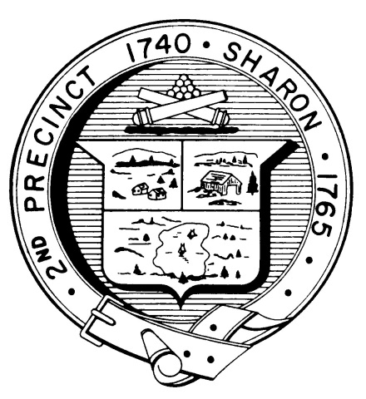

Town Clerk
TOWN OF SHARON

MEETING NOTICE

POSTED IN ACCORDANCE WITH THE OPEN MEETING LAW AS AMENDED

Board of Health

DATE: June 12, 2018

TIME: 7:00 pm

LOCATION: Community Center

AGENDA

- Meeting Minutes, May 17,2018 7:00 pm

- Article 7 7:05 pm

- Room/bedroom definition 7:15 pm

- Draft RFP for I/A Systems 7:30 pm

- Request regarding mosquito program 7:40 pm

- Health Department Report 7:50 pm

- Other business 8:00 pm

