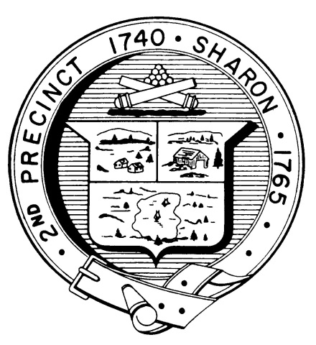

Town Clerk
TOWN OF SHARON

MEETING NOTICE

POSTED IN ACCORDANCE WITH THE OPEN MEETING LAW AS AMENDED

Board of Health

DATE: April 12, 2017

TIME: 7:00 pm

LOCATION: Sharon Community Center

AGENDA

- Minutes March 15 & February 15,2017 7:00 pm
- Master Planning Committee 7:05 pm
- Sharon Green Day 7:15 pm
- Radon Project 7:20 pm
- July 3rd Event 7:25 pm
- Zoning bylaw change 7:30 pm
- Tobacco Regulations 7:35 pm
- Health Department Report 8:35 pm
- Other business 8:40 pm

