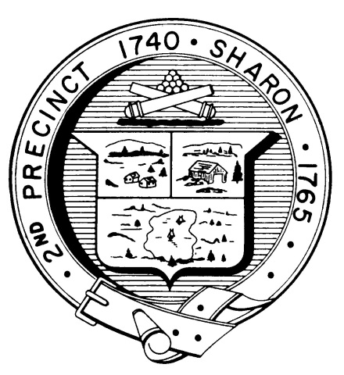

Town Clerk
TOWN OF SHARON

MEETING NOTICE

POSTED IN ACCORDANCE WITH THE OPEN MEETING LAW AS AMENDED

Board of Health

DATE: March 15, 2017

TIME: 7:00 pm

LOCATION: Sharon Community Center

AGENDA

- Minutes February 15,2017 meeting 7:00 pm
- Tobacco regulations update/review 7:05 pm

- Emergency Preparedness work plan 7:30 pm
- Sharon Green Day 7:35 pm
- Radon project 7:45 pm
- July 3rd event 8:00 pm
- Health Department Report 8:10 pm
- Other business 8:15 pm

