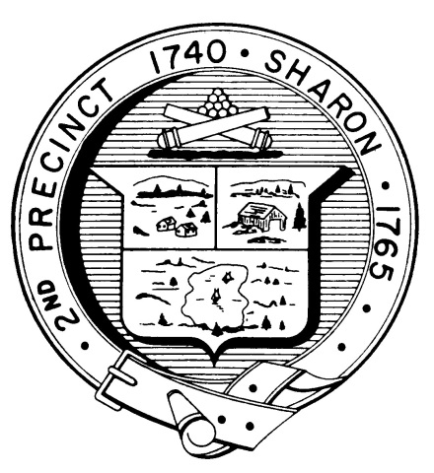

Town Clerk
TOWN OF SHARON

MEETING NOTICE

POSTED IN ACCORDANCE WITH THE OPEN MEETING LAW AS AMENDED

Board of Health

DATE: February 13, 2018

TIME: 7:00 pm

LOCATION: Sharon Community Center

AGENDA

- Meeting Minutes November
15 & 21, 2017; January 23, 2018 7:00 pm

- Type 1 Diabetes in school system 7:05 pm

- Body Art regulations and facility 7:15 pm

- Subsidized trash program 7:30 pm

- Proposed hotel/motel regulations 8:00 pm

- Health Department Report 8:30 pm

- Other business 8:40 pm

