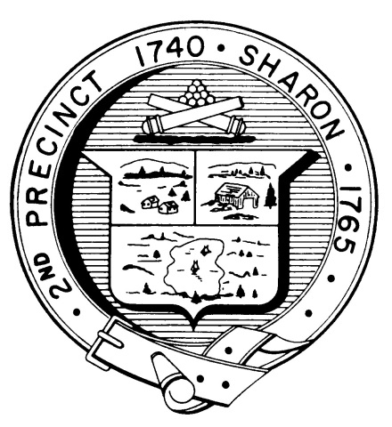

Town Clerk
TOWN OF SHARON

MEETING NOTICE

POSTED IN ACCORDANCE WITH THE OPEN MEETING LAW AS AMENDED

Board of Health

DATE: December 14, 2017

TIME: 3:00 pm

LOCATION: Sharon Community Center

AGENDA

- Meeting Minutes November 15 3:00 pm
& November 21, 2017

    - Hotel/Motel Issues-Proposed regulations 3:40 pm

    - Food licensing proposal 3:50 pm

    - Health Department Report 4:00 pm

    - Other business 4:05 pm

