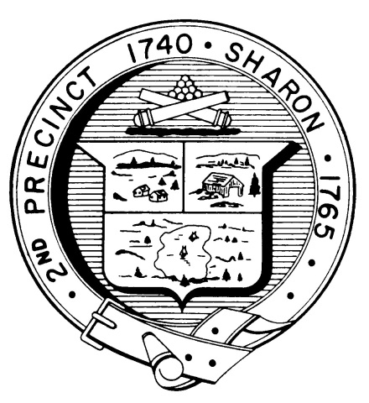

Town Clerk
TOWN OF SHARON

MEETING NOTICE

POSTED IN ACCORDANCE WITH THE OPEN MEETING LAW AS AMENDED

Board of Health

DATE: November 21, 2017

TIME: 10:00 am

LOCATION: Sharon Community Center

AGENDA

    - 269 Massapoag Ave variance, ET Eng.,
continuance: 10:00 am

    - 2019 Budget proposal 10:20 am

    - Other business 10:40 am

