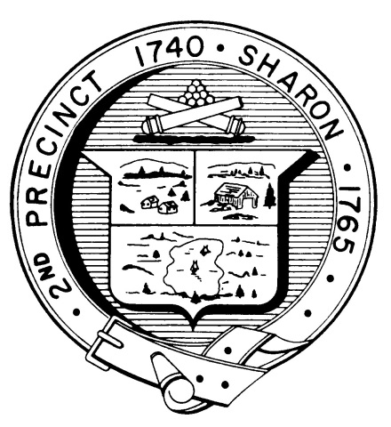

Town Clerk
TOWN OF SHARON

MEETING NOTICE

POSTED IN ACCORDANCE WITH THE OPEN MEETING LAW AS AMENDED

Board of Health

DATE: November 15, 2017

TIME: 7:00 pm

LOCATION: Sharon Community Center

AGENDA

    - Minutes of October 18,2017 meeting 7:00 pm

    - Indoor Air Quality, Council on Aging 7:05 pm

    - 269 Massapoag Ave variance, ET Eng. 7:10 pm

    - Lifeguards Semi-public pools 7:30 pm

    - 2019 Budget proposed 7:40 pm

    - Motel/Hotel Issues 7:50 pm

    - Licensing proposal food 8:00 pm

    - Health Department report 8:30 pm

    - Other business 8:45 pm

