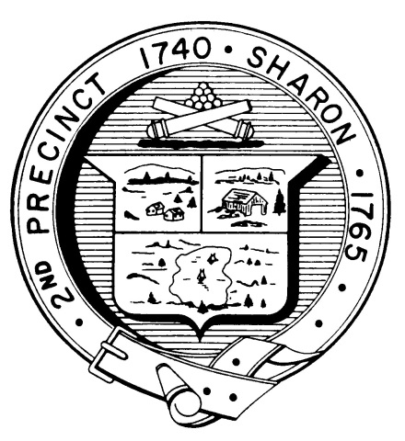

Town Clerk
TOWN OF SHARON

MEETING NOTICE

POSTED IN ACCORDANCE WITH THE OPEN MEETING LAW AS AMENDED

Board of Health

DATE: January 23, 2018

TIME: 7:00 pm

LOCATION: Sharon Community Center

AGENDA

- Meeting Minutes November
15 & 21, 2017; December 14, 2017 7:00 pm

- 7 Mitchell Street, septic variance 7:05 pm

- 25 Tiot Street, wastewater system 7:20 pm

- Temple Kol Tikvah permit 7:30 pm

- Lifeguard requirements 7:40 pm

- Proposed hotel/motel regulations 8:00 pm

- Body art permit fee and application 8:15 pm

- Health Department Report 8:30 pm

- Other business 8:40 pm

