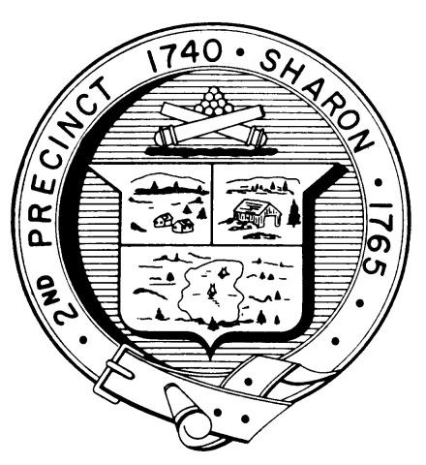

Town Clerk
TOWN OF SHARON

MEETING NOTICE

POSTED IN ACCORDANCE WITH THE PROVISIONS OF M.G.L. CHAPTER 39 SECTION 23A AS AMENDED.

FINANCE COMMITTEE
Monday, February 24, 2020
7:30 p.m.
Select Board Meeting Room, Town Hall, 90 South Main Street

AGENDA

- Discuss proposed Annual Town Meeting Non-Budget Articles:
- COA alternates; Zoning bylaw restricting locations for firearm sales (Rob Maidman)
- Stormwater bylaw; water discharge bylaw (Peter O’Cain)
- Review Sector Budgets

Reserve fund transfer request relating to Town Clerk transition – Fred Turkington, Town Administrator
- Liaison Updates:

Sharon Schools - Bill Brack
  - Library - Charles Goodman
  - Planning Board - Arnie Cohen
  - Standing Building Committee - Gordon Gladstone

Minutes to be voted: February 10, 2020

Topics not reasonably anticipated by the Chair in 48 hours

Adjournment

Next meetings: March 2nd: School budget
March 9th: Article 4/Personnel Board, Library budget, School budget cont.
March 23rd: Review general government budget sector, vote articles
March 30th: Vote operating and capital budgets, financial articles;
Complete review and vote articles.
(Fincom warrant write-up deadline Thursday April 2)

Note: Items may not be discussed in the order listed or at the specific time estimated.
Times are approximate.

The meeting likely will be broadcast and videotaped for later broadcast by
Sharon Community Television

