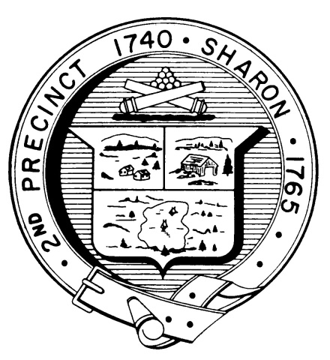

Town Clerk
TOWN OF SHARON

MEETING NOTICE

POSTED IN ACCORDANCE WITH THE PROVISIONS OF M.G.L. CHAPTER 39 SECTION 23A AS AMENDED.

FINANCE COMMITTEE
Wednesday, January 8, 2020
7:00 p.m.
Sharon Middle School, 75 Mountain Street

AGENDA

- Sharon Schools Fiscal Update to the School Committee and Finance Committee - Q2 Budget Report
  - The Finance Committee will be attending the Sharon School Committee meeting and part of a joint committee discussion for this agenda item.

Next meetings: January 27th
February 10th
February 24th

Note: Items may not be discussed in the order listed or at the specific time estimated.
Times are approximate.

The meeting likely will be broadcast and videotaped for later broadcast by
Sharon Community Television

