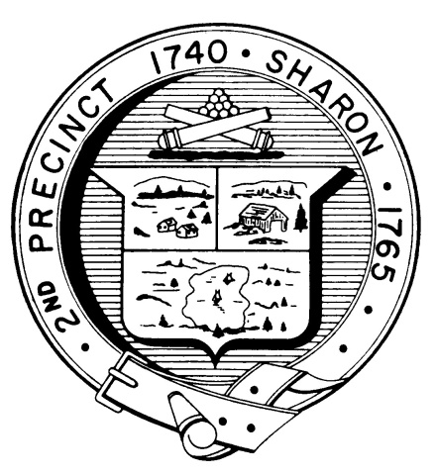

Town Clerk
TOWN OF SHARON

MEETING NOTICE

POSTED IN ACCORDANCE WITH THE PROVISIONS OF M.G.L. CHAPTER 39 SECTION 23A AS AMENDED.

FINANCE COMMITTEE
Monday, March 26th, 2018
7:30 p.m.
Town Hearing Room, Community Center, 219 Massapoag Avenue

AGENDA

- Community Preservation Committee Annual Funding and Projects – Corey Snow (to be confirmed)
- Trash and Recycling Fund – Fred Turkington
- Update on Marijuana Community Meetings and Revenue Data- Fred Turkington and Anja Bernier
- SharonCares, group advocating for limits on recreational marijuana, on the various marijuana articles –Connie Dai
- Four Daughters Compassionate Care, the medical marijuana licensee – Brian Striar and Stan Rosen
- Discuss Planning Board comments following the public hearing on March 15 relative to zoning articles, especially marijuana articles.
- Vote all pending Articles (except marijuana) – Finance Committee
- Documents Distributed Since Last Meeting
  - FY19 South East Regional expense
  - FY19 South East Regional FY19 Budget Hearing
  - School Revolving Fund fringe benefits
  - Executive Salary Survey
  - Revised Article 4 with actual salaries
  - Trash and Recycling Fund working budget
  - Revised Article List
- Vote Minutes
- Topics not reasonably anticipated by the chair in 48 hours
- Adjournment

Note: Items may not be discussed in the order listed or at the specific time estimated. Times are approximate.

The meeting likely will be broadcast and videotaped for later broadcast by Sharon Community Television

