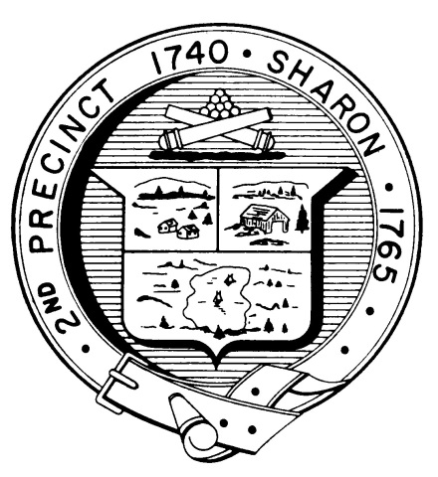

Town Clerk
TOWN OF SHARON

MEETING NOTICE

POSTED IN ACCORDANCE WITH THE OPEN MEETING LAW AS AMENDED

Board of Health
DATE: July 25, 2019

TIME: 7:00 pm

LOCATION: Community Center

AGENDA

- Meeting Minutes, June 12, 2019 7:05 pm

- Barnstable County program update 7:10 pm
with Emily Michele Olmsted

- Kevin Davis: 7:30 pm
-Storm water Management Plan
-Birch Hill Subdivision
-Outfall monitoring
-Storage unit

- Wingate food service update 8:00 pm

- Tobacco Regulations 8:10 pm

- High School plan review 8:30 pm

- Vaping Detectors 8:40 pm

- Beach conditions 8:45 pm

- Health Department Report 8:50 pm

- Other business 9:00 pm

