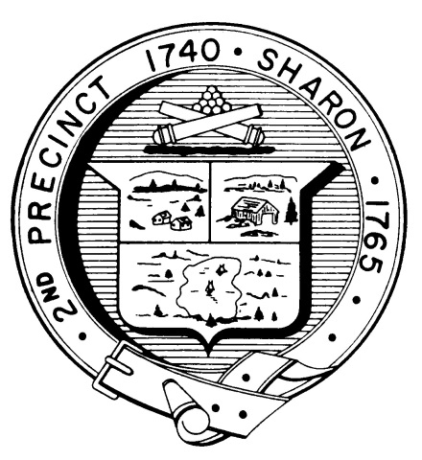

Town Clerk
TOWN OF SHARON

MEETING NOTICE

POSTED IN ACCORDANCE WITH THE OPEN MEETING LAW AS AMENDED

Board of Health

DATE: June 21, 2017

TIME: 7:00 pm

LOCATION: Sharon Community Center

AGENDA

- Minutes May 17,2017 7:00 pm
- Pool lifeguard variances 7:05 pm
- Tobacco regulations discussion 7:10 pm
- Philip Pitha-Gas line 7:40 pm
- PHEP Budget and updates 7:45 pm
- Fire pits 8:00 pm
- Recycled products policy 8:10 pm
- Health Department Report 8:40 pm
- Other business 8:45 pm

