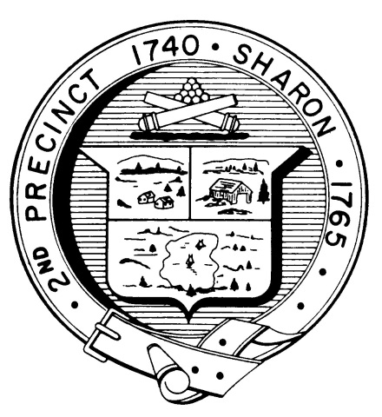

Town Clerk
TOWN OF SHARON

MEETING NOTICE

POSTED IN ACCORDANCE WITH THE OPEN MEETING LAW AS AMENDED

Board of Health

DATE: February 15, 2017

TIME: 7:00 pm

LOCATION: Sharon Community Center

AGENDA

- Minutes January 18,2017 meeting 7:00 pm
- Hearing Sharon Gallery 7:05 pm
- Hearing Unitarian Church exemption 7:20 pm

- Hearing 71R Glendale Road 7:40 pm

- Regulations codification vote 8:00 pm

- Tobacco regulations update 8:05 pm

- Emergency Preparedness work plan 8:10 pm
- Septic reporting 8:15 pm
- Organizational Analysis 8:20 pm

- Finance Committee meeting 8:25 pm
- Radon project proposal 8:30 pm
- Health Department Report 8:35 pm
- Other business 8:40 pm

