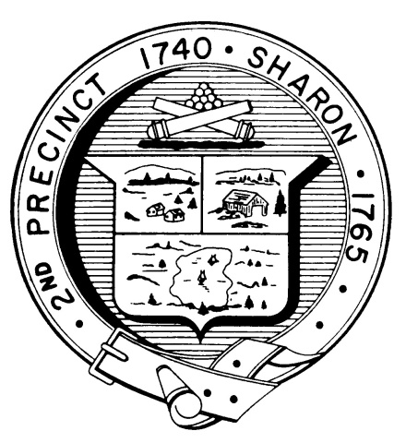

Town Clerk
TOWN OF SHARON

MEETING NOTICE

POSTED IN ACCORDANCE WITH THE PROVISIONS OF M.G.L. CHAPTER 39 SECTION 23A AS AMENDED.

FINANCE COMMITTEE
Monday, October 28, 2019
7:30 p.m.
Select Board Meeting Room, Town Hall, 90 South Main Street

AGENDA

OPEN WARRANT MEETING
Informal discussion of Warrant Articles

The Open Warrant Meeting is an opportunity to ask questions regarding the Finance Committee Recommendations in the Special Town Meeting Warrant.

Please take time to understand the issues.

Note: Items may not be discussed in the order listed or at the specific time estimated. Times are approximate.

The meeting likely will be broadcast and videotaped for later broadcast by Sharon Community Television

