TOWN OF SHARON
MEETING NOTICE

Posted in accordance M.G.L. c. 30A, §§ 18-25

Town Clerk
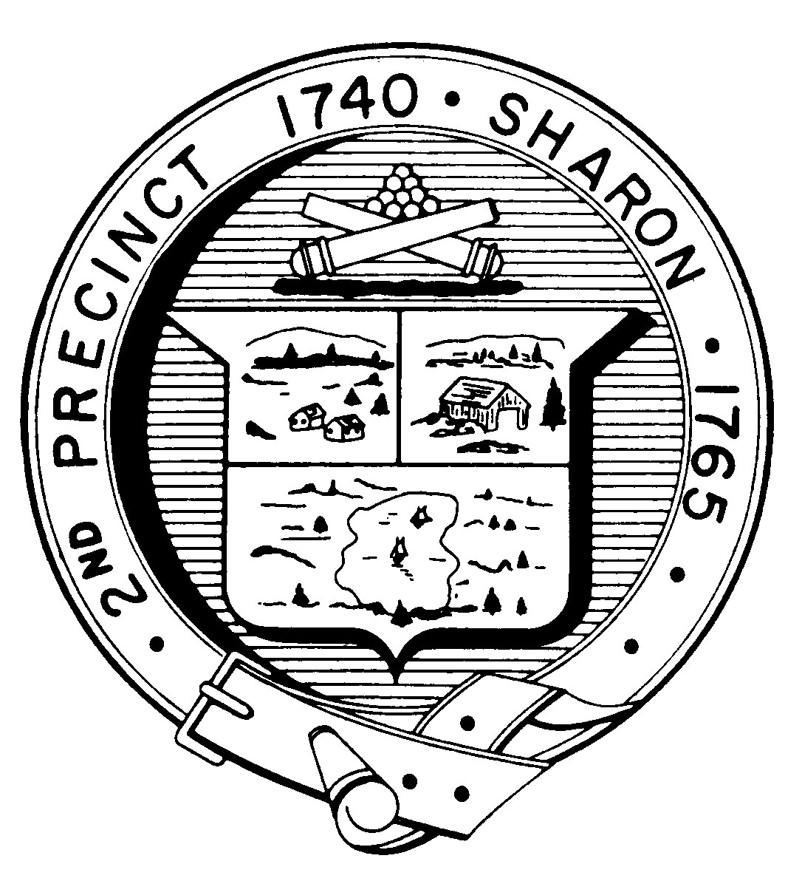

FINANCE COMMITTEE
Monday, November 9th, 2015
7:30 p.m.
Town Hearing Room, Community Center, 219 Massapoag Avenue

AGENDA

- Review of Options for Better Communication of Town Budget Information to Citizens of Sharon:
- Presentation by Alan Jones Visual Government Consortium
- Presentation by ClearGov

II. Update on FY 2017 Budget Process

III. Update on Budget Goals Process

IV. Approval of 10/26/2015 minutes

V. Other Topics Not Reasonably Anticipated

VI. Adjournment

Note: Items may not be discussed in the order listed or at the specific time estimated. Times are approximate.
The meeting likely will be broadcast and videotaped for later broadcast by Sharon Community Television.

