TOWN OF SHARON
MEETING NOTICE

Posted in accordance M.G.L. c. 30A, §§ 18-25

Town Clerk
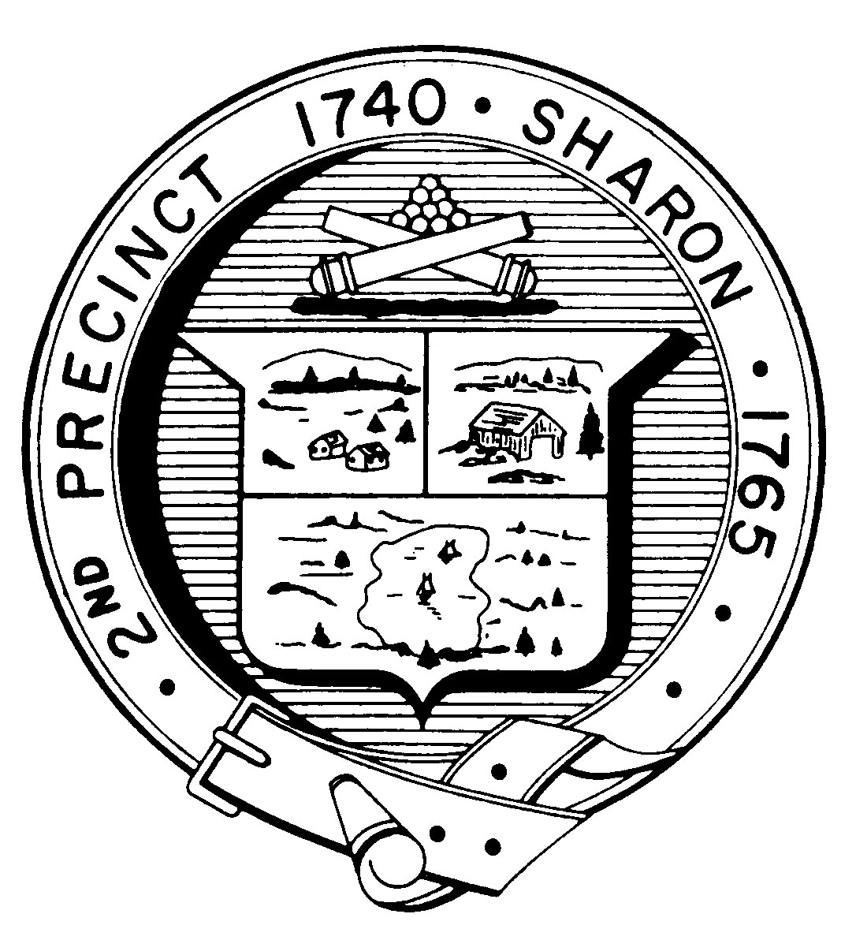

FINANCE COMMITTEE
Monday, October 26th, 2015
7:30 p.m.
Town Hearing Room, Community Center, 219 Massapoag Avenue

AGENDA

- Review and Discuss Potential Budget Policy items and make recommendations to Selectman/School Committee/Capital
1. Use of one time revenue
2. Maintaining Bond Rating
3. Others

II. Discuss Budget Sector Assignment for Finance Committee with Fred Tarkington

III. Discuss FY 2017 Budget
1. Finance Committee Sector

IV. Discuss implementation of comparative town analysis

V. Review and approve minutes

VI. Adjournment

Note: Items may not be discussed in the order listed or at the specific time estimated. Times are approximate.
The meeting likely will be broadcast and videotaped for later broadcast by Sharon Community Television.

