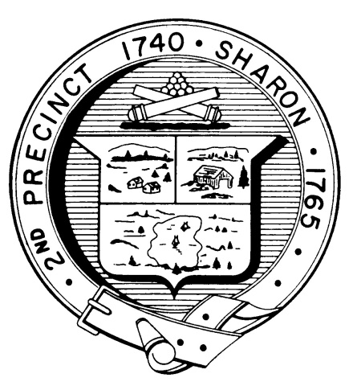

Town Clerk
TOWN OF SHARON

MEETING NOTICE

POSTED IN ACCORDANCE WITH THE PROVISIONS OF M.G.L. CHAPTER 39 SECTION 23A AS AMENDED.
FINANCE COMMITTEE
Monday, January 28th, 2018
7:30 p.m.
School Committee Meeting Room, Administrative Offices (second floor), Sharon Middle School, 75 Mountain Street
AGENDA

Review ATM Articles – Fred Turkington

Assign Warrant Writeups

Schedule Discussions with Proponents/Opponents and others

Liaison Updates:

Sharon Schools - Bill Brack
  - Library – Hanna Switlekowski
  - Planning Board – Arnie Cohen
  - Standing Building Committee – Gordon Gladstone

Documents Distributed Since the Last Meeting

Library Grant Award Notification
  - FY19 Second Quarter Financials
  - Materials for Three Board Meeting

Minutes to be voted: January 14th

Topics not reasonably anticipated by the Chair in 48 hours

Adjournment

Next Meetings: February 11th and 25th

No Meeting February 4th

Note: Items may not be discussed in the order listed or at the specific time estimated. Times are approximate.

The meeting likely will be broadcast and videotaped for later broadcast by Sharon Community Television.

