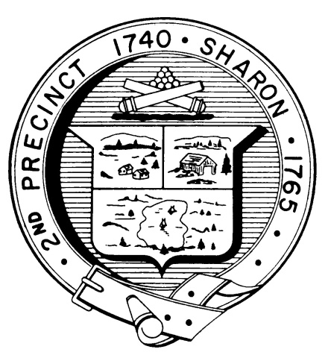

Town Clerk
TOWN OF SHARON

MEETING NOTICE

POSTED IN ACCORDANCE WITH THE PROVISIONS OF M.G.L. CHAPTER 39 SECTION 23A AS AMENDED.

FINANCE COMMITTEE
Monday, March 19th, 2018
7:30 p.m.
Town Hearing Room, Community Center, 219 Massapoag Avenue

AGENDA
- Board of Health Nuisance Article and FY19 initiatives - Beverly Anderson (Pending Confirmation)
- The Personnel Board Article 4 – Fred Turkington and Michael Feldman Town Counsel to Review Marijuana Legal Framework and Cannabis Control Commission Regulations - Dick Gelerman and Colleagues
- Discuss and Vote FY2019 Operating and Capital Budgets and Financial Articles – Committee
- Documents Distributed Since Last Meeting
- Vote Minutes
- Topics not reasonably anticipated by the chair in 48 hours
- Adjournment

Note: Items may not be discussed in the order listed or at the specific time estimated. Times are approximate.

The meeting likely will be broadcast and videotaped for later broadcast by Sharon Community Television

