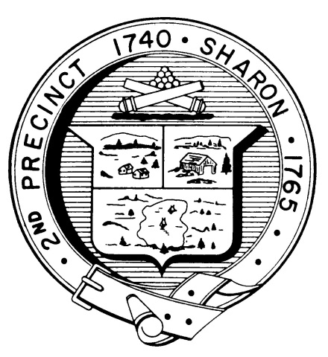

Town Clerk
TOWN OF SHARON

MEETING NOTICE

POSTED IN ACCORDANCE WITH THE OPEN MEETING LAW AS AMENDED

Board of Health

DATE: March 13, 2018

TIME: 7:00 pm

LOCATION: Sharon Community Center

AGENDA

- Meeting Minutes November 15, 2017;
February 13,2018 7:00 pm

- Kevin Davis, DPW introduction 7:05 pm

- Appointment of Lance DelPriore 7:10 pm

- Hearing: Hotel/Motel Regulations 7:15 pm

- I/A System testing requirements 7:45 pm

- Body Art regulations and facility 7:50 pm

- Subsidized trash program issues 8:00 pm

- Health Department Report 8:15 pm

- Other business 8:30 pm

