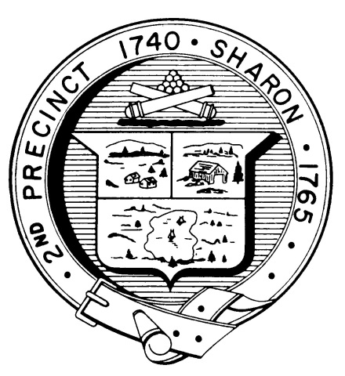

Town Clerk
TOWN OF SHARON

MEETING NOTICE

POSTED IN ACCORDANCE WITH THE OPEN MEETING LAW AS AMENDED

Board of Health

DATE: September 26, 2018

TIME: 6:00 pm

LOCATION: Sharon Public Safety Building

AGENDA

- Meeting Minutes, August 15,2018 6:00 pm

- Health Department Report 6:05 pm

- Tobacco regulations, DJ Wilson 6:15 pm

- Presentation on Vaping, E-cigarettes and health
Impacts 7:00 pm

- Dr. Lester Hartman MD, speaker

- DJ Wilson, regulatory issues

- Questions 8:15 pm

- Other business 8:30 pm

