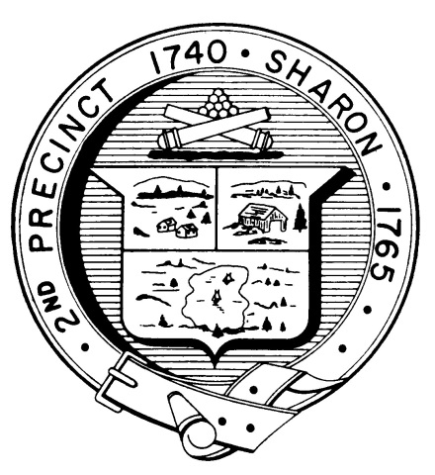

Town Clerk
TOWN OF SHARON

MEETING NOTICE

POSTED IN ACCORDANCE WITH THE OPEN MEETING LAW AS AMENDED

Board of Health

DATE: August 15, 2018

TIME: 7:00 pm

LOCATION: Sharon Community Center

AGENDA

- Meeting Minutes, July 26,2018 7:00 pm

- Steven Gioiosa, Birch Hill Subdivision 7:05 pm

- Subsidized Trash Program update 7:30 pm

- Discussion on Paradigm recommendations 7:40 pm

- Health Department Report 7:50 pm

- Other business 8:00 pm

