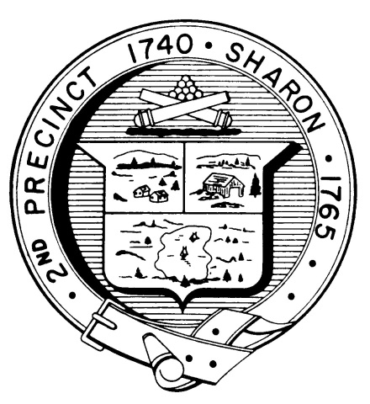

Town Clerk
TOWN OF SHARON

MEETING NOTICE

POSTED IN ACCORDANCE WITH THE OPEN MEETING LAW AS AMENDED

Board of Health

DATE: July 26, 2018

TIME: 7:00 pm

LOCATION: Community Center

AGENDA

- Meeting Minutes, June 12,2018 7:00 pm

- Health Department Report 7:05 pm

- Subsidized trash issues 7:10 pm

- Vaping, Flavored tobacco issues 7:15 pm

- Article 7 revisions-Kevin Davis 7:20 pm

- Other business 7:30 pm

