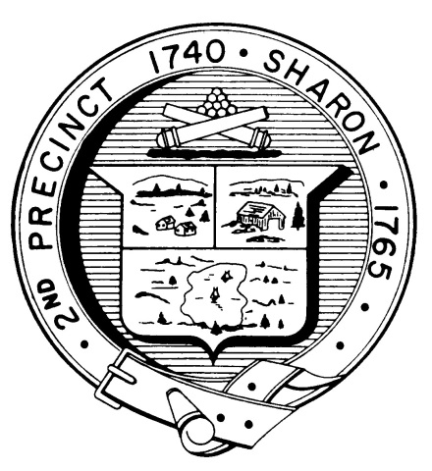

Town Clerk
TOWN OF SHARON

MEETING NOTICE

POSTED IN ACCORDANCE WITH THE OPEN MEETING LAW AS AMENDED

Board of Health

DATE: April 25, 2018

TIME: 7:00 pm

LOCATION: Sharon Community Center

AGENDA

- Meeting Minutes, March 26,2018 7:00 pm

- 127 Beach Street, D. Oberlander 7:10 pm

- Appointment of Kevin Davis as health agent 7:15 pm

- Septic revolving fund proposal 7:30 pm

- Innovative/Alternative Systems 7:45 pm

- Hotel/Motel Regulations update 8:00 pm

- Health Department Report 8:15 pm

- Other business 8:30 pm

